Week5_Assignment1_CS-540-10148-M01 Data Literacy & Visualization 2026
Module Five Activity Guidelines and Rubric
CS 540 Module Five Activity Guidelines and Rubric
Overview
Creating clear, effective data visualizations is a foundational skill in data analysis, research, and professional communication. In many roles, professionals are expected to turn raw data into visual formats that inform decision making, reveal patterns, or communicate results to a non-technical audience.
Directions
In this activity, you will write Python code to create clear and informative data visualizations from a selected data set. Your code should be well-organized and reflect a clear understanding of each step in the visualization process. When you are ready to begin your work, access Codio by clicking the title of the next task.
Before you begin, check out the data set located in the Module Five Activity data folder in Codio. Then, in the Jupyter Notebook, complete the following steps:
- Write the necessary code in the "To Do;" placeholder code blocks. Use the comments to guide your code.
- Run each code block successfully before doing the next.
- At the end, restart Kernel and run all the code end-to-end to generate six visuals.
- Save the visuals in PNG file formats, making sure to add calls to display the images as output.
When the assignment is complete, download the HTML version of your project by clicking on File, then Download As, then HTML (.html) from the Jupyter menu bar. Save the file to your local machine.
Note: if the code block was not run in the Notebook, it may not render in the HTML output of the Notebook. To fix missing blocks, run the code block, then download as HTML.
Specifically, you must address the following rubric criteria:
Part One: Data Visualizations
- Prepare the given data set for visualization. Consider the following:
  - Are there any columns you can remove?
  - Are filters or groupings needed?
  - Are the data values structured for your chart types?
- Clean the given data set for visualization using Python. Consider the following:
  - Are there any missing or invalid values?
  - Are there any unclear column names?
  - Are the data types correct for each column (e.g., numeric, categorical, datetime)?
- Create multiple types of visualizations using Python. Include the following:
  - Dendrogram
  - PCA scatterplot
  - Cluster size distribution
  - Feature importance heatmap
  - Trend chart
  - Scatterplot
Part Two: Reflection
- Identify patterns in the data. Consider the following:
  - Are there any clear trends, clusters, or outliers visible in your visualizations?
  - Are certain variables showing consistent behavior or relationships?
  - Are the patterns similar across different visualization types?
- Draw conclusions from the patterns. Consider the following:
  - Are your conclusions clearly based on the patterns you observed?
  - Are your findings supported by multiple visuals or data points?
- Explain how the visualizations validate your findings. Consider the following:
  - Are specific chart elements (e.g., color, scale, labels) helping to highlight your findings?
  - Are the insights you found something you could not easily see without the visuals?
- Write a summary of the visualization choices you made. Include the following:
  - Explanation of the types of charts you used
  - Explanation of how your formatting decisions support visual clarity
What to Submit
To complete this activity, you must submit the following:
Data Visualizations
Download your Jupyter Notebook as an HTML file. Review the file to ensure the code ran successfully and visualizations are displayed. Submit the HTML file.
Reflection
Submit your reflection as a 1-page Microsoft Word document with double-spacing, 12-point Times New Roman font, and one-inch margins.
AI Usage
If you use gen AI tools to support your work on this assignment, be sure to follow these AI usage guidelines. You must acknowledge your use of these tools in your work. Guidelines on how to cite AI tools can be found in this Shapiro Library guide.
Codio:-
https://codio.com/kjoshi131918118/5-3-activity--visualize-the-insight--exploring-patterns-with-python
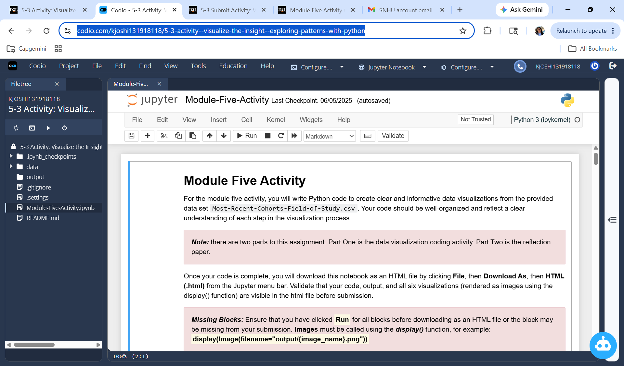
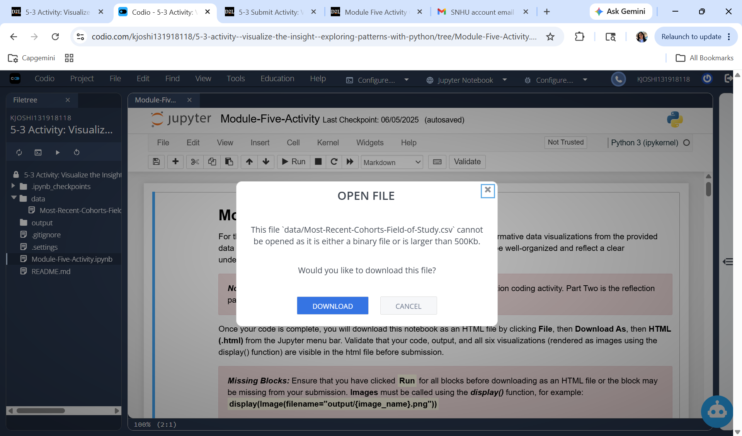

SNHU UID:khushbu.joshi@snhu.edu
PWD:Aryaman@26

